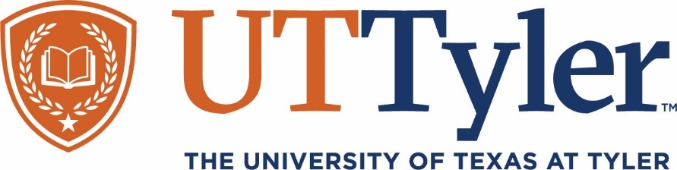

**Monthly *Grand Rounds* – Teams Broadcast**

***Sponsored and Coordinated by The Department of Medical Education***

[Click here to join the meeting](https://teams.microsoft.com/l/meetup-join/19%3ameeting_MDMwOThjOTgtYzFlMi00OTcyLTljZDgtYTE0ODM3N2YyMjIz%40thread.v2/0?context=%7b%22Tid%22%3a%225f5c2410-cd60-4dbe-b97e-3c9c38140272%22%2c%22Oid%22%3a%22916a304d-eab1-46aa-b99e-6b309f27be39%22%7d) 0**r call in (audio only)**

[+1 430-205-1142,,579066628#](tel:+14302051142,,579066628# ) , Tyler Phone Conf. ID: 579 066 628#

**Tuesday, September 20, 2022**

**12:00-1:00pm**

**COPD 2022: Where we are and where we are going**

**Speaker:**

**Alexander Duarte, MD**

**Professor, Pulmonary Critical Care & Sleep Medicine**

**Internal Medicine,**

**University of Texas Medical Branch, Galveston**

**Objectives:**

At the end of this presentation, participants should have increased information to discuss and improve diagnosis and symptom assessment, review pharmacologic treatment strategies and use of phenotypes to optimize therapy and examine non-pharmacologic strategies to reduce morbidity and mortality of COPD.

***Grand Rounds are designed for physicians, residents and medical students and are available to other health care professionals with an interest in the program being presented.***



 **ABIM MOC Credit**

Successful completion of this CME activity, which includes participation in the evaluation component, enables the participant to earn up to one (1) MOC point in the American Board of Internal Medicine’s (ABIM) Maintenance of Certification (MOC) program. Participants will earn MOC points equivalent to the amount of CME credits claimed for the activity. It is the CME activity provider’s responsibility to submit participant completion information to ACCME for the purpose of granting ABIM MOC credit.